**PAYROLL MANAGEMENT SYSTEM**

**Developers:**

Gomer Gaufo Jr.

Reymond Viñas

John Kenneth Nacion

Mico Andes

Clark Balane

#include <iostream>

#include <fstream>

using namespace std;

class PayrollAdmin {

private:

int payrollId;

string payrollFrom;

string payrollTo;

int id;

string fname;

string lname;

int payHour;

int totalHour;

string attendance;

int timeIn, timeOut;

public:

void home();

void payslip();

void dashboard();

void list();

void employeeAttendance();

void employeeTimeIn();

void employeeTimeOut();

void addEmployee();

void editEmployee();

void removeEmployee();

void logout();

};

class EmployeePortal {

private:

int employeeId;

int timeIn, timeOut;

string employeePass;

int id;

string fname;

string lname;

int payHour;

int totalHour;

public:

void employeeLogin();

void employeeHome();

void employeeInfo();

void employeePayslip();

void employeeTotalHour();

void employeeLogout();

};

**Main Function**

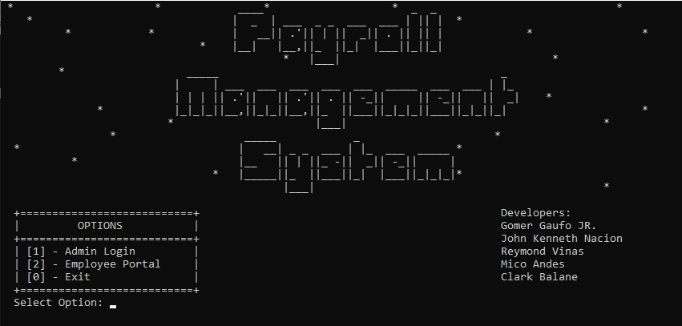

int main(){

int choice;

EmployeePortal myObj;

do{

cout << " * * ____* * _ _ * " << endl;

cout << " * | _ | ___ _ _ ___ ___ | || | * " << endl;

cout << " * * | __|| .'|| | || _|| . || || | * *" << endl;

cout << " * |__| |__,||_ ||_| |___||_||_| " << endl;

cout << " * |___| * " << endl;

cout << " * _____ _ " << endl;

cout << " | | ___ ___ ___ ___ ___ _____ ___ ___ | |_ " << endl;

cout << " | | | || .'|| || .'|| . || -_|| || -_|| || _| * " << endl;

cout << " * |_|_|_||__,||_|_||__,||_ ||___||_|_|_||___||_|_||_| *" << endl;

cout << " * |___| * " << endl;

cout << " * _____ _ * " << endl;

cout << " * | __| _ _ ___ | |_ ___ _____ * " << endl;

cout << " * |__ || | ||_ -|| _|| -_|| | " << endl;

cout << " * |_____||_ ||___||_| |___||_|_|_|* " << endl;

cout << " |___| * " << endl;

cout << endl;

cout << " +===========================+ Developers:" << endl;

cout << " | OPTIONS | Gomer Gaufo JR." << endl;

cout << " +===========================+ John Kenneth Nacion" << endl;

cout << " | [1] - Admin Login | Reymond Vinas" << endl;

cout << " | [2] - Employee Portal | Mico Andes" << endl;

cout << " | [0] - Exit | Clark Balane" << endl;

cout << " +===========================+" << endl;

cout << " Select Option: ";

cin >> choice;

switch(choice){

case 1:

system("cls");

login();

break;

case 2:

system("cls");

myObj.employeeLogin();

break;

case 0:

exit(0);

break;

}

system("cls");

cout << " +======================+" << endl;

cout << " | ERROR CHOICE |" << endl;

cout << " +======================+" << endl;

} while(choice != 0);

return 0;

}

**Admin Login**

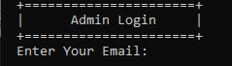

void login(){

string email, password;

PayrollAdmin myObj;

cout << " +======================+" << endl;

cout << " | Admin Login |" << endl;

cout << " +======================+" << endl;

cout << " Enter Your Email: ";

cin >> email;

cout << " Enter Your Password: ";

cin >> password;

if(email == "admin" && password == "admin"){

system("cls");

myObj.home();

} else {

system("cls");

cout << " +======================+" << endl;

cout << " | INVALID LOGIN |" << endl;

cout << " +======================+" << endl;

login();

}

}

**Admin Home**

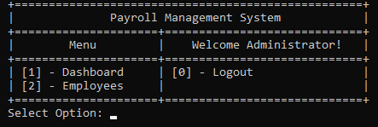

void PayrollAdmin::home(){

system("cls");

int choice;

do{

cout << endl;

cout << " +===================================================+" << endl;

cout << " | Payroll Management System |" << endl;

cout << " +=====================+=============================+" << endl;

cout << " | Menu | Welcome Administrator! |" << endl;

cout << " +=====================+=============================+" << endl;

cout << " | [1] - Dashboard | [0] - Logout |" << endl;

cout << " | [2] - Employees | |" << endl;

cout << " +=====================+=============================+" << endl;

cout << " Select Option: ";

cin >> choice;

switch(choice){

case 1:

system("cls");

dashboard();

break;

case 2:

system("cls");

list();

break;

case 0:

logout();

break;

default:

home();

}

} while(choice != 0);

}

**Admin Dashboard**

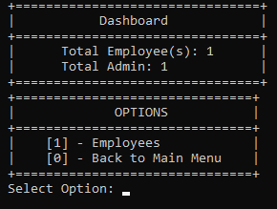

void PayrollAdmin::dashboard(){

system("cls");

int totalEmployee, choice;

fstream data;

data.open("employees.txt");

data >> id >> fname >> lname >> payHour >> totalHour >> timeIn >> timeOut;

while(data){

totalEmployee = id;

data >> id >> fname >> lname >> payHour >> totalHour >> timeIn >> timeOut;

}

data.close();

cout << " +================================+" << endl;

cout << " | Dashboard |" << endl;

cout << " +================================+" << endl;

cout << " | Total Employee(s): " << totalEmployee << " |" << endl;

cout << " | Total Admin: 1 |" << endl;

cout << " +================================+" << endl;

cout << " +===============================+" << endl;

cout << " | OPTIONS |" << endl;

cout << " +===============================+" << endl;

cout << " | [1] - Employees |" << endl;

cout << " | [0] - Back to Main Menu |" << endl;

cout << " +===============================+" << endl;

cout << " Select Option: ";

cin >> choice;

switch(choice){

case 1:

system("cls");

list();

break;

case 0:

system("cls");

home();

break;

default:

dashboard();

}

}

**List of employee**

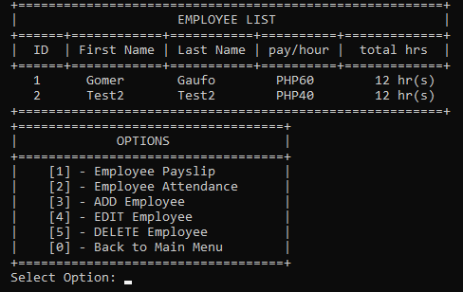

void PayrollAdmin::list(){

int choice, totalEmployeeHour;

fstream data;

data.open("employees.txt");

data >> id >> fname >> lname >> payHour >> totalHour >> timeIn >> timeOut;

cout << " +========================================================+" << endl;

cout << " | EMPLOYEE LIST |" << endl;

cout << " +======+============+===========+==========+=============+" << endl;

cout << " | ID | First Name | Last Name | pay/hour | total hrs |"<< endl;

cout << " +======+============+===========+==========+=============+" << endl;

if(data.is_open()){

while(!data.eof()){

if(timeIn != 0 && timeOut != 0){

totalEmployeeHour = timeOut - timeIn;

} else {

totalEmployeeHour = totalHour;

}

cout << " " << id << "\t " << fname << "\t" << lname << "\t PHP" << payHour << "\t " << totalEmployeeHour;

cout << " hr(s)" << endl;

data >> id >> fname >> lname >> payHour >> totalHour >> timeIn >> timeOut;

}

data.close();

} else {

cout << "database not found!";

}

cout << " +========================================================+" << endl;

cout << " +===================================+" << endl;

cout << " | OPTIONS |" << endl;

cout << " +===================================+" << endl;

cout << " | [1] - Employee Payslip |" << endl;

cout << " | [2] - Employee Attendance |" << endl;

cout << " | [3] - ADD Employee |" << endl;

cout << " | [4] - EDIT Employee |" << endl;

cout << " | [5] - DELETE Employee |" << endl;

cout << " | [0] - Back to Main Menu |" << endl;

cout << " +===================================+" << endl;

cout << " Select Option: ";

cin >> choice;

switch(choice){

case 1:

payslip();

break;

case 2:

employeeAttendance();

break;

case 3:

addEmployee();

break;

case 4:

editEmployee();

break;

case 5:

removeEmployee();

break;

case 0:

system("cls");

home();

break;

default:

system("cls");

list();

}

}

**Payslip**

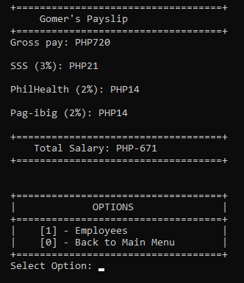

void PayrollAdmin::payslip(){

int employeeId, choice, totalEmployeeHour;

int grossPay, totalSalary, tax, sss, philHealth, pagIbig;

cout << " +=======================================+" << endl;

cout << " | Employee's Payslip' |" << endl;

cout << " +=======================================+" << endl;

cout << " Enter emplyee's ID: ";

cin >> employeeId;

fstream data;

data.open("employees.txt");

data >> id >> fname >> lname >> payHour >> totalHour >> timeIn >> timeOut;

while(!data.eof()){

if(employeeId == id){

if(timeIn != 0 && timeOut != 0){

totalEmployeeHour = timeOut - timeIn;

} else {

totalEmployeeHour = totalHour;

}

system("cls");

grossPay = payHour * totalEmployeeHour;

sss = 0.03 * grossPay;

philHealth = 0.02 * grossPay;

pagIbig = 0.02 * grossPay;

totalSalary = (sss + philHealth + pagIbig) - grossPay;

cout << endl;

cout << " +===================================+" << endl;

cout << " " << fname << "'s Payslip " << endl;

cout << " +===================================+" << endl;

cout << " Gross pay: PHP" << grossPay << endl;

cout << endl;

cout << " SSS (3%): PHP" << sss << endl;

cout << endl;

cout << " PhilHealth (2%): PHP" << philHealth << endl;

cout << endl;

cout << " Pag-ibig (2%): PHP" << pagIbig << endl;

cout << endl;

cout << " +===================================+" << endl;

cout << " Total Salary: PHP" << totalSalary << " " << endl;

cout << " +===================================+" << endl;

cout << endl << endl;

data.close();

cout << " +===================================+" << endl;

cout << " | OPTIONS |" << endl;

cout << " +===================================+" << endl;

cout << " | [1] - Employees |" << endl;

cout << " | [0] - Back to Main Menu |" << endl;

cout << " +===================================+" << endl;

cout << " Select Option: ";

cin >> choice;

switch(choice){

case 1:

system("cls");

list();

break;

case 0:

home();

break;

default:

system("cls");

list();

break;

}

} else {

data >> id >> fname >> lname >> payHour >> totalHour >> timeIn >> timeOut;

}

}

list();

}

**Attendance**

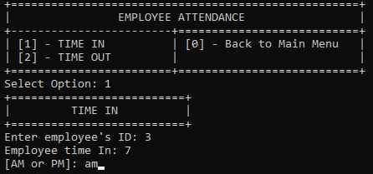

void PayrollAdmin::employeeAttendance() {

int choice, employeeId, emIn, emOut;

string timeChoose;

cout << " +====================================================+" << endl;

cout << " | EMPLOYEE ATTENDANCE |" << endl;

cout << " +------------------------+===========================+" << endl;

cout << " | [1] - TIME IN | [0] - Back to Main Menu |" << endl;

cout << " | [2] - TIME OUT | |" << endl;

cout << " +========================+===========================+" << endl;

cout << " Select Option: ";

cin >> choice;

switch(choice){

case 1:

employeeTimeIn();

break;

case 2:

employeeTimeOut();

break;

case 0:

system("cls");

home();

break;

default:

system("cls");

employeeAttendance();

}

}

**Attendance (Time in)**

void PayrollAdmin::employeeTimeIn(){

int employeeId, emIn;

string timeChoice;

cout << " +==========================+" << endl;

cout << " | TIME IN |" << endl;

cout << " +==========================+" << endl;

cout << " Enter employee's ID: ";

cin >> employeeId;

fstream data, data2;

data.open("employees.txt");

data2.open("employees2.txt", ios::app | ios::out);

data >> id >> fname >> lname >> payHour >> totalHour >> timeIn >> timeOut;

while(data){

if(employeeId == id){

if(timeIn == 0){

cout << " Employee time In: ";

cin >> emIn;

cout << " [AM or PM]: ";

cin >> timeChoice;

if (timeChoice == "PM" || timeChoice == "pm") {

emIn += 12;

} else if(timeChoice == "AM" || timeChoice == "am"){

} else{

cout << " Please Choose Again" << endl;

cout << " [AM or PM]: ";

cin >> timeChoice;

}

data2 << id << " " << fname << " " << lname << " " << payHour << " " << totalHour << " " << emIn << " " << timeOut << endl;

system("cls");

cout << " +=============================================================+ " << endl;

cout << " SUCCESSFULLY ADDED TIME IN ATTENDANCE FOR " << fname << " " << endl;

cout << " +=============================================================+ " << endl;

} else {

system("cls");

cout << " +==========================================================+ " << endl;

cout << " | TIME IN ATTENDANCE ALREADY ADDED FOR THIS EMPLOYEE | " << endl;

cout << " +==========================================================+ " << endl;

data2 << id << " " << fname << " " << lname << " " << payHour << " " << totalHour << " " << timeIn << " " << timeOut << endl;

}

} else {

data2 << id << " " << fname << " " << lname << " " << payHour << " " << totalHour << " " << timeIn << " " << timeOut << endl;

}

data >> id >> fname >> lname >> payHour >> totalHour >> timeIn >> timeOut;

}

data.close();

data2.close();

remove("employees.txt");

rename("employees2.txt", "employees.txt");

list();

}

**Attendance (Time in)**

void PayrollAdmin::employeeTimeOut(){

int employeeId, emOut;

string timeChoice;

cout << " +==========================+" << endl;

cout << " | TIME OUT |" << endl;

cout << " +==========================+" << endl;

cout << " Enter employee's ID: ";

cin >> employeeId;

fstream data, data2;

data.open("employees.txt");

data2.open("employees2.txt", ios::app | ios::out);

data >> id >> fname >> lname >> payHour >> totalHour >> timeIn >> timeOut;

while(data){

if(employeeId == id){

if(timeIn == 0){

system("cls");

cout << " +===========================================================+ " << endl;

cout << " | YOU NEED TO ADD TIME IN FIRST FOR THIS EMPLOYEE! | " << endl;

cout << " +===========================================================+ " << endl;

data.close();

data2.close();

remove("employees2.txt");

list();

} else {

if(timeOut == 0){

cout << " Employee time Out: ";

cin >> emOut;

cout << " [AM or PM]: ";

cin >> timeChoice;

if (timeChoice == "PM" || timeChoice == "pm") {

emOut += 12;

}

else if(timeChoice == "AM" || timeChoice == "am"){

}

else{

cout << " Please Choose Again" << endl;

cout << " [AM or PM]: ";

cin >> timeChoice;

}

data2 << id << " " << fname << " " << lname << " " << payHour << " " << totalHour << " " << timeIn << " " << emOut << endl;

system("cls");

cout << " +=============================================================+ " << endl;

cout << " SUCCESSFULLY ADDED TIME OUT ATTENDANCE FOR " << fname << " " << endl;

cout << " +=============================================================+ " << endl;

}

else {

system("cls");

cout << " +=============================================================+ " << endl;

cout << " | TIME OUT ATTENDANCE ALREADY ADDED FOR THIS EMPLOYEE | " << endl;

cout << " +=============================================================+ " << endl;

data2 << id << " " << fname << " " << lname << " " << payHour << " " << totalHour << " " << timeIn << " " << timeOut << endl;

}

}

}

else {

data2 << id << " " << fname << " " << lname << " " << payHour << " " << totalHour << " " << timeIn << " " << timeOut << endl;

}

data >> id >> fname >> lname >> payHour >> totalHour >> timeIn >> timeOut;

}

data.close();

data2.close();

remove("employees.txt");

rename("employees2.txt", "employees.txt");

list();

}

**Add Employee**

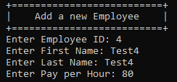

void PayrollAdmin::addEmployee(){

cout << " +==========================+" << endl;

cout << " | Add a new Employee |" << endl;

cout << " +==========================+" << endl;

cout << " Enter Employee ID: ";

cin >> id;

cout << " Enter First Name: ";

cin >> fname;

cout << " Enter Last Name: ";

cin >> lname;

cout << " Enter Pay per Hour: ";

cin >> payHour;

fstream data;

data.open("employees.txt", ios::app | ios::out);

if(data.is_open()){

data << id << " " << fname << " " << lname << " " << payHour << " " << 0 << " " << 0 << " " << 0 << " \n";

data.close();

} else {

cout << "Error with database:(" << endl;

}

fstream database;

database.open("database.txt", ios::app | ios::out);

if(database.is_open()){

database << id << " " << fname << endl;

database.close();

}

system("cls");

cout << " +=======================================+" << endl;

cout << " | New Employee Added |" << endl;

cout << " +=======================================+" << endl;

list();

}

**Edit Employee**

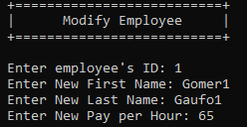

void PayrollAdmin::editEmployee(){

int employeeId, newEmployeeId, newPayHour, newTotalHour;

string newFname, newLname;

fstream data, data2;

cout << " +==========================+" << endl;

cout << " | Modify Employee |" << endl;

cout << " +==========================+" << endl;

cout << endl;

cout << " Enter employee's ID: ";

cin >> employeeId;

data.open("employees.txt");

if(!data){

cout << "Error with database:(" << endl;

}

data2.open("employees2.txt", ios::app | ios::out);

data >> id >> fname >> lname >> payHour >> totalHour >> timeIn >> timeOut;

while(!data.eof()){

if(employeeId == id){

cout << " Enter New First Name: ";

cin >> newFname;

cout << " Enter New Last Name: ";

cin >> newLname;

cout << " Enter New Pay per Hour: ";

cin >> newPayHour;

data2 << id << " " << newFname << " " << newLname << " " << newPayHour << " " << totalHour << " " << timeIn << " " << timeOut << "\n";

system("cls");

cout << " +==============================================+" << endl;

cout << " | Successfully Editing Employee |" << endl;

cout << " +==============================================+" << endl;

} else {

data2 << id << " " << fname << " " << lname << " " << payHour << " " << totalHour << " " << timeIn << " " << timeOut << "\n";

}

data >> id >> fname >> lname >> payHour >> totalHour >> timeIn >> timeOut;

}

data.close();

data2.close();

remove("employees.txt");

rename("employees2.txt", "employees.txt");

system("cls");

list();

}

**Remove Employee**

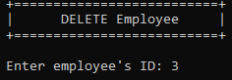 

void PayrollAdmin::removeEmployee(){

int employeeId;

fstream data, data2;

cout << " +==========================+" << endl;

cout << " | DELETE Employee |" << endl;

cout << " +==========================+" << endl;

cout << endl;

cout << " Enter employee's ID: ";

cin >> employeeId;

data.open("employees.txt");

data2.open("employees2.txt", ios::app | ios::out);

data >> id >> fname >> lname >> payHour >> totalHour >> timeIn >> timeOut;

while(!data.eof()){

if(employeeId == id){

system("cls");

cout << " +==============================================+" << endl;

cout << " | Successfully Removing Employee |" << endl;

cout << " +==============================================+" << endl;

} else {

data2 << id << " " << fname << " " << lname << " " << payHour << " " << totalHour << " " << timeIn << " " << timeOut << "\n";

}

data >> id >> fname >> lname >> payHour >> totalHour >> timeIn >> timeOut;

}

data.close();

data2.close();

remove("employees.txt");

rename("employees2.txt", "employees.txt");

fstream database, database2;

database.open("database.txt");

database >> id >> fname;

database2.open("database2.txt", ios::app | ios::out);

while(!database.eof()){

if(employeeId == id){

system("cls");

cout << " +==============================================+" << endl;

cout << " | Successfully Removing Employee |" << endl;

cout << " +==============================================+" << endl;

} else {

database2 << id << " " << fname << endl;

}

database >> id >> fname;

}

database.close();

database2.close();

remove("database.txt");

rename("database2.txt", "database.txt");

list();

}

**Logout (Admin)**



void PayrollAdmin::logout(){

system("cls");

int choice;

cout << " +===================================+" << endl;

cout << " | Successfully logged out! |" << endl;

cout << " +===================================+" << endl;

main();

}

**Employee Login**

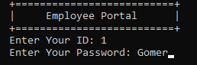

void EmployeePortal::employeeLogin(){

fstream data;

int id;

string password;

cout << " +==========================+" << endl;

cout << " | Employee Portal |" << endl;

cout << " +==========================+" << endl;

cout << " Enter Your ID: ";

cin >> id;

cout << " Enter Your Password: ";

cin >> password;

data.open("database.txt");

data >> employeeId >> employeePass;

while(data){

if(id == employeeId){

if(password == employeePass){

employeeId = id;

employeePass = password;

data.close();

employeeHome();

} else {

system("cls");

cout << " +======================+" << endl;

cout << " | INVALID LOGIN |" << endl;

cout << " +======================+" << endl;

employeeLogin();

}

} else {

data >> employeeId >> employeePass;

}

}

system("cls");

data.close();

cout << " +======================+" << endl;

cout << " | ERROR LOGIN |" << endl;

cout << " +======================+" << endl;

employeeLogin();

}

**Employee Home**

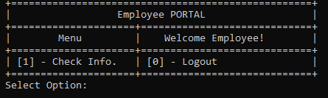

void EmployeePortal::employeeHome() {

system("cls");

int choice;

cout << " +===================================================+" << endl;

cout << " | Employee PORTAL |" << endl;

cout << " +=====================+=============================+" << endl;

cout << " | Menu | Welcome Employee! |" << endl;

cout << " +=====================+=============================+" << endl;

cout << " | [1] - Check Info. | [0] - Logout |" << endl;

cout << " +=====================+=============================+" << endl;

cout << " Select Option: ";

cin >> choice;

switch(choice){

case 1:

employeeInfo();

break;

case 0:

employeeLogout();

break;

}

}

**Check Info**

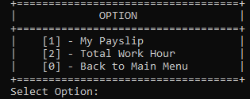

void EmployeePortal::employeeInfo(){

system("cls");

int choice;

cout << " +===================================+" << endl;

cout << " | OPTION |" << endl;

cout << " +===================================+" << endl;

cout << " | [1] - My Payslip |" << endl;

cout << " | [2] - Total Work Hour |" << endl;

cout << " | [0] - Back to Main Menu |" << endl;

cout << " +===================================+" << endl;

cout << " Select Option: ";

cin >> choice;

switch(choice){

case 1:

employeePayslip();

break;

case 2:

employeeTotalHour();

break;

default:

system("cls");

employeeHome();

break;

}

}

**My Payslip**

void EmployeePortal::employeePayslip() {

int choice, totalEmployeeHour;

int grossPay, totalSalary, tax, sss, philHealth, pagIbig;

fstream data;

data.open("employees.txt");

data >> id >> fname >> lname >> payHour >> totalHour >> timeIn >> timeOut;

while(data){

if(employeeId == id){

if(timeIn != 0 && timeOut != 0){

totalEmployeeHour = timeOut - timeIn;

} else {

totalEmployeeHour = totalHour;

}

grossPay = payHour * totalEmployeeHour;

sss = 0.03 * grossPay;

philHealth = 0.02 * grossPay;

pagIbig = 0.02 * grossPay;

totalSalary = (sss + philHealth + pagIbig) - grossPay;

system("cls");

cout << endl;

cout << " +===================================+" << endl;

cout << " | YOUR PAYSLIP |" << endl;

cout << " +===================================+" << endl;

cout << " Gross pay: PHP" << grossPay << endl;

cout << endl;

cout << " SSS (3%): PHP" << sss << endl;

cout << endl;

cout << " PhilHealth (2%): PHP" << philHealth << endl;

cout << endl;

cout << " Pag-ibig (2%): PHP" << pagIbig << endl;

cout << endl;

cout << " +===================================+" << endl;

cout << " Total Salary: PHP" << totalSalary << " " << endl;

cout << " +===================================+" << endl;

cout << endl;

cout << " +===================================+" << endl;

cout << " | OPTION |" << endl;

cout << " +===================================+" << endl;

cout << " | [0] - Back to Main Menu |" << endl;

cout << " +===================================+" << endl;

cout << " Select Option: ";

cin >> choice;

switch(choice){

case 0:

employeeHome();

break;

default:

system("cls");

employeePayslip();

break;

}

} else {

data >> id >> fname >> lname >> payHour >> totalHour >> timeIn >> timeOut;

}

}

}

**Total Work Hour**

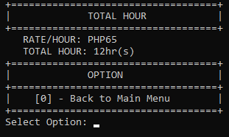

void EmployeePortal::employeeTotalHour() {

system("cls");

int choice, totalEmployeeHour;

fstream data;

data.open("employees.txt");

data >> id >> fname >> lname >> payHour >> totalHour >> timeIn >> timeOut;

while(data){

if(employeeId == id){

if(timeIn != 0 && timeOut != 0){

totalEmployeeHour = timeOut - timeIn;

} else {

totalEmployeeHour = totalHour;

}

cout << " +===================================+" << endl;

cout << " | TOTAL HOUR |" << endl;

cout << " +===================================+" << endl;

cout << " RATE/HOUR: PHP" << payHour<< endl;

cout << " TOTAL HOUR: " << totalEmployeeHour << "hr(s)" << endl;

cout << " +===================================+" << endl;

cout << " | OPTION |" << endl;

cout << " +===================================+" << endl;

cout << " | [0] - Back to Main Menu |" << endl;

cout << " +===================================+" << endl;

data.close();

cout << " Select Option: ";

cin >> choice;

switch(choice){

case 0:

employeeHome();

break;

default:

system("cls");

employeeTotalHour();

break;

}

} else {

data >> id >> fname >> lname >> payHour >> totalHour >> timeIn >> timeOut;

}

}

}

**Logout (Employee)**

